Monitoring and Evaluation Report: Truth Speaks Spoken Word Competition (2025)

Introduction

About the Project
The Truth Speaks Spoken Word Competition is a branch of the Truth Speaks Project - a creative advocacy initiative that uses spoken word and storytelling to promote peace, justice, and strong institutions in Nigeria. This first edition led by Citizens Initiatives for Rights and Empowerment (CITIZINRE) and powered by Project Bar, an initiative of Akinboro and Co., encourages law students and young lawyers to reflect on their role in advancing Sustainable Development Goal 16. Through competitions, live events, and digital platforms, Truth Speaks provides a space for legal professionals to share ideas on access to justice, human rights, and good governance in ways that are engaging, inclusive, and culturally relevant. The project was designed to address gaps in legal awareness, civic participation, and rights education, especially among young people and rural communities. By blending modern technology with indigenous languages and storytelling traditions, it seeks to spark dialogue on the role of law in building stronger communities. The project also supports the preservation of local languages and cultural expression as powerful tools for advocacy and public enlightenment. At its core, Truth Speaks aims to inspire a new generation of legal advocates who are not only skilled in the courtroom but are also active voices in the movement for social justice, equality, and good governance. The initiative provides opportunities for participants to connect their legal knowledge with pressing societal issues and to use creative expression to reach and educate wider audiences.

Objectives of the M&E Report
The purpose of this monitoring and evaluation (M&E) report is to assess how well Truth Speaks “SDG 16” edition has delivered on its goals during the reporting period. It focuses on measuring the project’s reach, participation, and influence on civic awareness, legal knowledge, and engagement among its target groups. The report also provides evidence on how the project has contributed to promoting legal rights education, preserving indigenous storytelling, and encouraging dialogue on justice and governance.
This M&E report is designed to provide useful insights for the project team, partners, and supporters, highlighting both achievements and areas for improvement. By documenting key findings and lessons learnt, the report helps ensure that future phases of Truth Speaks can build on what has worked well and address identified challenges. It also aims to strengthen accountability to stakeholders and demonstrate the value of creative advocacy in advancing social justice.

Scope and Reporting Period
This report covers the activities and outcomes of the Truth Speaks “SDG 16” project from May to July 2025. It focuses on key components of the project, including the spoken word competition, social media engagement, and pre- and post-engagement surveys. The report tracks participation numbers, diversity of submissions, and shifts in civic knowledge and interest.
The scope of this M&E exercise includes both quantitative data, such as submission counts, and digital reach, and qualitative insights drawn from participant feedback. While this report concentrates on the specific reporting period, it also draws attention to trends and lessons that can inform the planning and delivery of future phases of Truth Speaks.

Monitoring and Evaluation Approach

Indicators Tracked
The monitoring and evaluation approach for Truth Speaks “SDG 16” was guided by the project’s goal of measuring not just participation but also the wider influence on civic awareness and legal advocacy. The project used a mix of data sources to capture both reach and impact. These included social media analytics to measure digital visibility, competition records to track submissions, and surveys to understand shifts in knowledge, interest, and engagement. This combination allowed the team to gather evidence on how well the project connected with its audience and sparked meaningful dialogue around peace, justice, and strong institutions.

Tools and Methods
The data for this report was gathered through practical tools and simple methods designed to suit the nature of the project. Social media platforms, particularly Instagram, provided data on impressions, views, comments, and shares. The team also tracked the number and type of submissions, paying attention to the use of indigenous languages and the diversity of participants. Pre- and post-engagement surveys were used to measure changes in awareness, interest, and knowledge among participants and the wider audience.

Findings

Social Media Reach and Engagement
The Truth Speaks project recorded strong digital engagement during the reporting period, with noticeable growth in online visibility and audience interaction. Over the course of the project, the Truth Speaks Instagram page gained 481 new followers, showing growing interest and attention from the legal and wider civic community. A total of 19 spoken word entries were shared publicly on the page, and together they received over 53,000 views. These posts sparked more than 5,000 interactions, including over 2,500 likes, 1,500 comments, around 60 saves, and over 500 shares. This level of engagement indicates not only that the content reached a wide audience but also that it resonated strongly, prompting people to react, comment, and share it with others.
Among all content types shared during the period, including announcements and event highlights, the spoken word pieces stood out clearly as the most impactful. They generated the highest number of views and interactions, confirming that storytelling and creative advocacy remain effective tools for reaching and engaging diverse audiences on issues of justice, governance, and civic responsibility.

Participation Metrics
The competition received a total of 26 submissions, with an even gender distribution (13 males and 13 females) showcasing balanced representation among participants. In terms of age, the majority (19 participants, 70%) fell within the 25–31 age range, while another 6 participants (22%) were between 18–24 years. This closely aligns with the project’s focus on young lawyers and law school graduates, the primary group the initiative seeks to engage in critical conversations about justice and civic responsibility, deepen understanding of SDG 16 – Peace, Justice and Strong Institutions and encourage legal professionals to take more active roles in public dialogue and legal empowerment. One participant was aged 32–40, suggesting that the project also appealed, though marginally, to slightly older legal professionals with an interest in creative civic expression.
Geographically, the submissions reflected moderate diversity, with representation from all six of Nigeria’s geopolitical zones. The South West (Lagos – 9 submissions), North Central (FCT – 9 submissions), and South East (Enugu – 3 submissions) had the highest representation, followed by the South South (Bayelsa – 1, Rivers – 1). The North West (Kano – 1 submission) and North East (Yola – 1 submission) were notably underrepresented, highlighting a significant gap in northern participation. (See Figure 1)
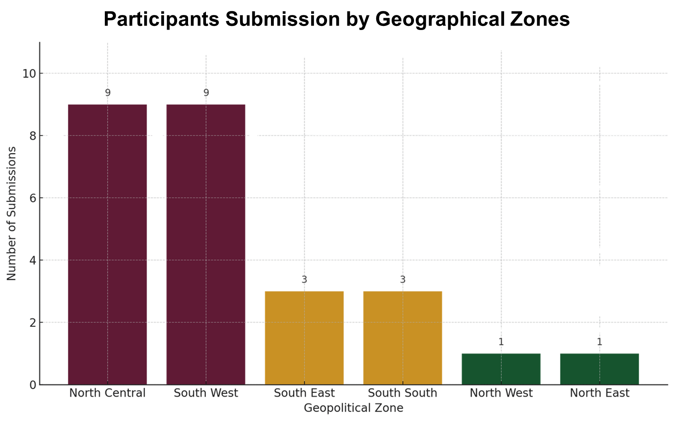
Figure 1: Submissions by geographical locations
A closer look at the state of origin further confirms a southern skew, with the most entries coming from states like Abia, Anambra, Bayelsa, Edo, Enugu Imo, while many northern and middle-belt states were unrepresented. This imbalance highlights the need for more targeted outreach and localized publicity in underrepresented regions, particularly in the North East and North West — to ensure broader participation and truly national representation in future editions of the project.
Taken together, both state and campus data point to the need for a more intentional inclusion strategy. Future editions of Truth Speaks would benefit from deeper collaboration with campus representatives, and legal associations in northern Nigeria, alongside tailored communication efforts in local languages. This would not only enhance geographical diversity but also uphold the project’s commitment to inclusivity, civic dialogue, and national representation.

Civic Awareness and Knowledge Shift
A key goal of Truth Speaks was to go beyond artistic expression and stimulate a deeper civic understanding among young legal professionals. To measure this, participants completed a short survey before and after their engagement with the competition. The results show clear shifts in knowledge, awareness, and willingness to engage in civic advocacy.
Awareness of SDG 16 significantly improved following participation. Before the project, only 5 participants described themselves as "very familiar" with SDG 16, while 6 were only "somewhat familiar," and 5 had merely "heard of it, but didn’t know the details." After participating in Truth Speaks, the number of those who considered themselves "very familiar" nearly tripled to 14, with just 2 still reporting limited knowledge. (see figure 2) This shows that the project served as a strong learning platform for connecting legal practice with global development goals. Some of the participants highlights
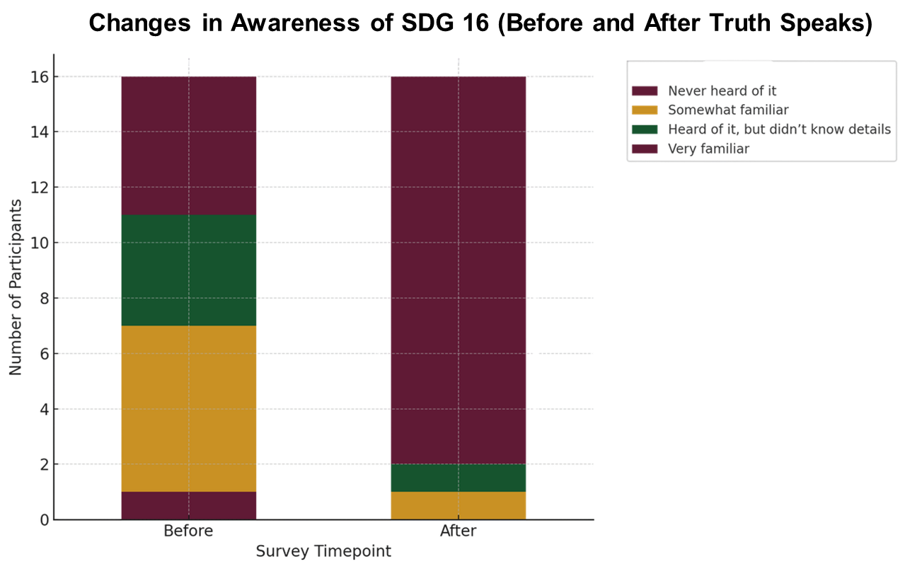
Figure 2: Changes In Awareness of SDG 16.
"Before Truth Speaks, I only had a surface-level idea of SDG 16. Now I see how it affects the way we live, especially for people who can't afford lawyers or don’t know their rights."
"It was eye-opening to learn how lawyers can be more than courtroom figures; they can be advocates for peace and justice."
"...the project served as a strong learning platform for connecting legal practice with global development goals."
Understanding of the role of lawyers in promoting justice and civic rights also saw a notable improvement. Before the competition, 10 participants "strongly agreed" that lawyers have a key role to play in advancing justice within Nigerian communities, while 6 others simply "agreed." Following their engagement with Truth Speaks, the number of participants who strongly agreed rose to 14, reflecting not just increased awareness, but a deeper sense of conviction and a stronger appreciation of the lawyer’s responsibility in shaping a just society. (See Figure 3)
"It made me realise that being a lawyer isn’t just about litigation. It’s about speaking up and standing in the gap for those who can’t."
"Now I understand that law is not just a profession, it’s a service to society”
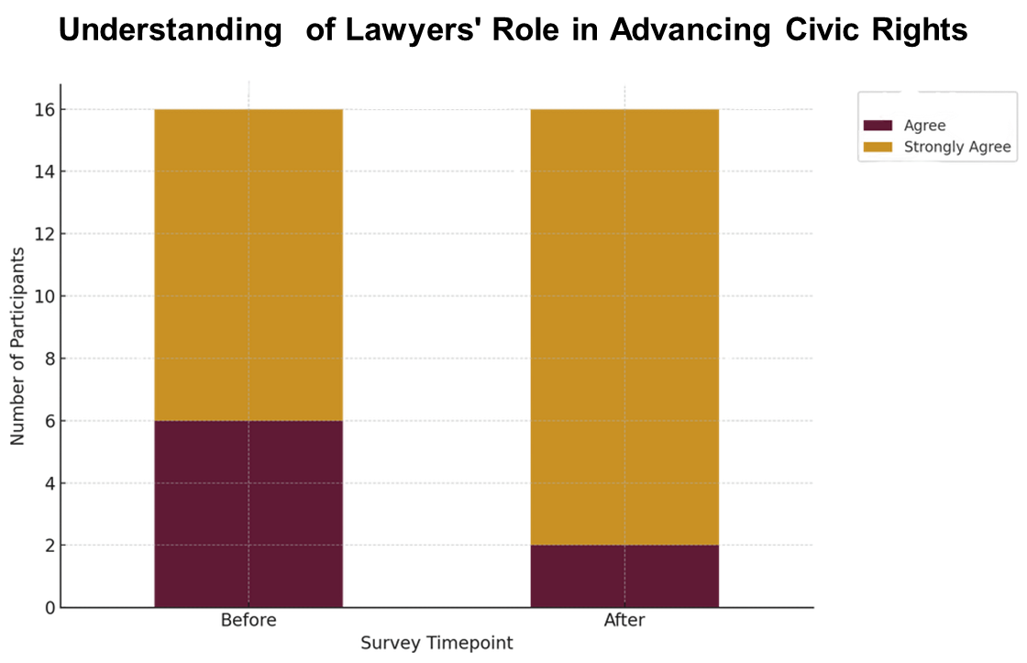
Figure 3: Participants Knowledge of Role of Lawyers in promoting justice and civic rights in Nigerian communities
Importantly, the initiative also sparked a stronger interest in legal advocacy and governance among participants. Prior to the competition, 10 respondents indicated they were interested in learning more about justice, law, and governance. After engaging with Truth Speaks, this number rose to 14, with a clear shift from general agreement to "strongly agree" responses, suggesting that the project deepened participants' curiosity and motivation to understand how legal systems affect everyday lives. (See Figure 4)
Truth Speaks rekindled something in me - a desire to explore the law’s power beyond textbooks and courtrooms."
"...to understand how legal systems affect everyday lives."
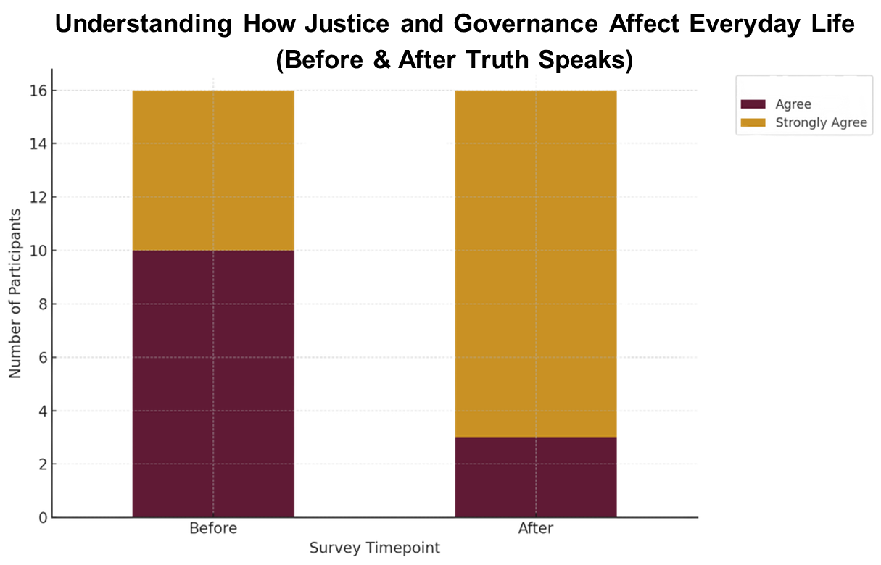
Figure 4: Participants understanding of how justice and governance affect everyday life
Among the compelling evidence of impact lies in participants’ intentions to take action. Before the competition, only 7 respondents described themselves as "very likely" to create or engage with content related to social justice or legal rights. By the end of the project, all 16 participants reported that they were now "very likely" to do so, marking a clear transition from passive awareness to active civic expression and public advocacy. (See Figure 5)
I am taking away a greater passion for advocacy and using my voice to speak up for justice."
"Before this, I never thought about law as something I could communicate through poetry. Now I see it as a tool for change.
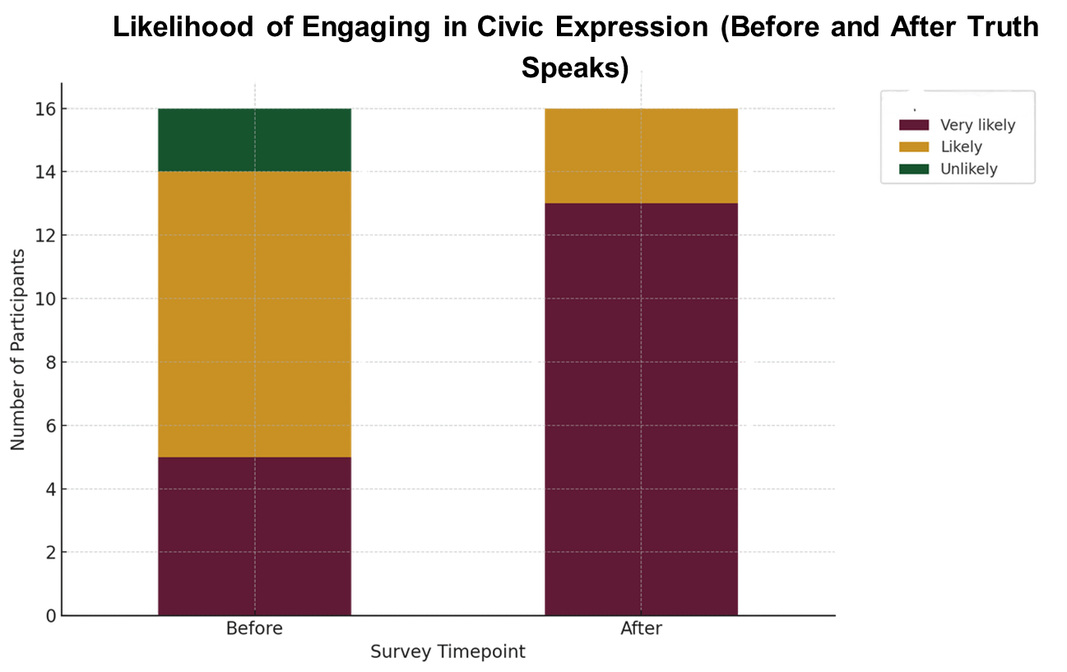
Figure 5: Likelihood of participants engaging in civic expressions and activities

Recommendation

Enhance Outreach in Underserved Regions
The low number of entries from the North West and absence of submissions from the North East point to a clear geographic gap in participation. Future rounds should involve proactive outreach to northern campuses, particularly through law school administrations, student bar associations, and faculty leads. Using region-specific communication channels such as WhatsApp groups, alumni clusters, and institutional newsletters can help ensure the competition reaches a broader and more diverse pool of aspiring legal advocates.

Sustain Engagement Beyond the Competition
Several participants expressed strong interest in continuing their involvement in civic and legal advocacy after the competition. To maintain this momentum, a follow-up platform such as a community newsletter, group chat, or peer support forum can provide space for ongoing dialogue, idea-sharing, and collaboration. This sustained engagement would not only deepen learning but also help build a network of young legal professionals committed to promoting justice and civic responsibility.

